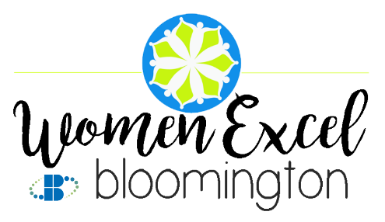
FOR IMMEDIATE RELEASE:
Bloomington Chamber Now Accepting Nominations for the
2020 Women Excel Bloomington Awards

Bloomington, IN – March 11, 2020 - The Greater Bloomington Chamber of Commerce is excited to announce it is now accepting nominations for the 11th Annual Women Excel Bloomington (WEB) Awards. Each year, seven women are recognized for their outstanding leadership in influencing the growth of others in the community and/or in their professional organization. These prestigious business leadership awards will be presented at the WEB Awards reception scheduled for late May.

WEB nominees serve as an inspiration, helping others to excel as they lead by example. They may be employed in either the business sector or a non-profit organization. Other criteria include:
- The nominees must be at least 21 years of age or older.
- Chamber membership is not required; EXCEPT for nominees who live outside of Monroe County, must be a Chamber member in good standing.
- Nominees cannot be a previous WEB honoree.
- Nominees should balance their professional contributions with demonstrated leadership through community service or in volunteer capacities.

“The Chamber’s WEB Awards continue to inspire and celebrate the dedication and hard work of women in our community,” said Erin Predmore, president and CEO of the Greater Bloomington Chamber of Commerce. “Since 2010, we have been able to honor so many women who have gone above and beyond to serve the greater Bloomington community, and we are looking forward to seeing the nominations we receive from our members and the community for this year’s celebration.”

Nominations may be submitted on the Chamber’s website (ChamberBloomington.org). A nomination form is also available online or by calling the Chamber at 812.336.6381. All nominations, electronic or printed, should be submitted to the Chamber on or before Monday, April 13, 2020 at 5:00p.m.

About the Greater Bloomington Chamber of Commerce:
The Greater Bloomington Chamber of Commerce is a nonprofit membership organization serving as our community’s leading advocate for business. We offer unique leadership opportunities, meaningful volunteer activities, and exclusive business-building programs focused on critical economic, civic, and social priorities. Chamber members support each other and community initiatives, sharing information and resources to help create economic opportunity and community well-being. At the Greater Bloomington Chamber of Commerce, we believe that better business leads to a better community.

Contact:
Rachel Levy
Marketing & Communications Coordinator
812-336-6381
rlevy@chamberbloomington.org
https://www.chamberbloomington.org/

# # #

